Competitive Analysis: Once Upon a Chef
Target App: Once Upon a Chef (onceuponachef.com) Core Angle: Family-friendly tested recipes backed by professional culinary training.

What works
As a home cook who wants food to look and taste like it came from a restaurant but doesn't have hours to spend on experimental guesswork, I find that Once Upon a Chef hits the absolute sweet spot for reliability and visual clarity. Here is what works wonderfully:
- Flawless, Step-by-Step Culinary Guidance: Unlike typical recipe blogs where you are left guessing what "sear until brown" or "whisk to soft peaks" actually looks like, Jenn provides gorgeous, high-resolution step-by-step photos for every key transition of the recipe. Seeing the exact color of the sautéed garlic or the texture of the dough before it goes in the oven takes all the cooking anxiety away.
- Meticulously Tested Recipes: Every recipe feels professionally bulletproof. When the recipe says "cook for 3 minutes on high," it actually takes exactly 3 minutes on high to achieve the desired result. Jenn's culinary school training and professional kitchen background shine through in the precise instructions.
- Friction-Free "Jump to Recipe" and Print Options: Right at the very top of the page, under the main mouth-watering hero photo, there is an easy-to-spot 'Jump to Recipe' button. When I'm in the middle of a grocery run or cooking on a busy weeknight, this lets me bypass the introductory narrative and immediately access the ingredient amounts and instructions.
- In-Depth Ingredient Explanations: Before the recipe card, there is a breakdown of why specific ingredients are used and what substitutions are safe. For example, explaining why unsalted butter is preferred or how a specific cut of steak behaves under high heat makes me a smarter cook.
- Thriving, Authentic Community Reviews: The review section isn't just full of generic "looks good!" comments. Real users post helpful details like "I substituted Greek yogurt for sour cream and it worked beautifully" or "took 5 minutes longer in my convection oven." It feels like having a supportive community in the kitchen with me.

What doesn’t work
While the recipes themselves are absolute triumphs, the digital user interface has some frustrating gaps that get in the way of a modern kitchen experience:
- No Dynamic Serving Scale / Yield Adjuster: This is a major pain point. If a recipe is written for 4 people and I want to cook a romantic dinner for 2 or host a party of 8, the recipe card is completely static. I have to pull out a calculator and scratchpad to manually scale down or multiply the ingredients. In baking, this is incredibly risky and leads to avoidable mistakes.
- No US Customary to Metric Conversion Toggle: For a site that preaches culinary precision and recommends weighing flour on a digital scale, it is highly disappointing that there is no automatic unit converter. The recipes are presented solely in US customary measurements (cups, tablespoons, ounces). If you want to bake using grams or live outside the US, you are forced to use a separate app to convert every ingredient.
- Lack of an Interactive "Cook Mode" (Screen Wake Lock): Cooking is a messy, hands-on activity. When I’m holding raw chicken or have flour-dusted fingers, the last thing I want to do is touch my phone screen because it timed out and went black. The website lacks a dedicated, full-screen 'Cook Mode' that keeps the device screen awake and presents instructions in large, high-contrast, swipeable steps.
- Ad-Heavy and Slow Page Navigation: To support a free recipe blog, there are a lot of intrusive advertisements. Floating video players that follow you down the page, auto-scrolling banners, and interstitial pop-ups frequently block the recipe steps or step-by-step photos. This can cause the page to lag on mobile devices in the middle of cooking.
- Overly Basic Search and Filter Options: The site's search tool is a simple text input. You cannot do a faceted search like "gluten-free + dinner + under 30 minutes" or filter by multiple ingredients in your fridge. You are limited to broad predefined categories or typing keyword queries.

Recipe library patterns
When browsing for inspiration, the recipe index uses a clean, high-impact grid pattern:
- Visually Dominant Grids: The main browsing pages use a clean three-column grid on desktop and a single column on mobile. Each card features a massive, professionally styled photo of the finished dish.
- Instant Social Proof: Every card displays the dish title, a star-rating system (filled gold stars), and the total number of reviews. This makes it instantly obvious which recipes are community favorites (like her legendary Big Soft Ginger Cookies or Perfect Peach Crisp).
- Broad, Simple Taxonomy: The navigation menu categorizes recipes by meal type (Dinner, Dessert, Breakfast), preparation style (Quick & Easy, Make-Ahead), or basic dietary needs (Gluten-Free, Vegetarian). It is incredibly straightforward, though it lacks deep nesting or custom sorting options (like sorting by rating or cook time).
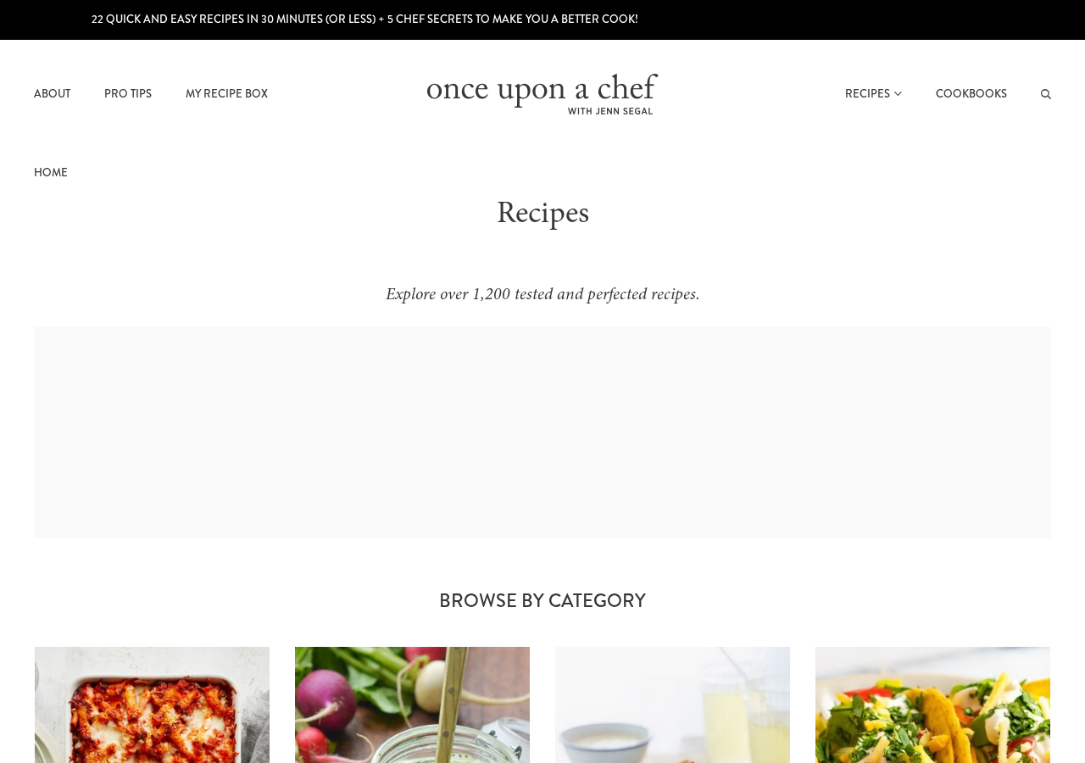
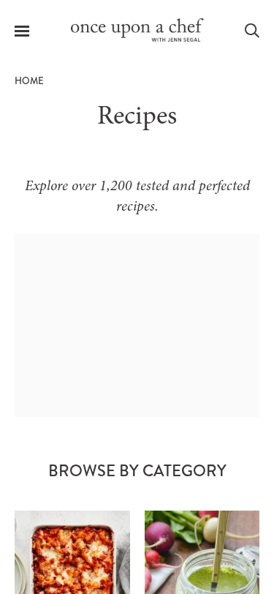

Recipe detail patterns
Once you select a recipe, the page follows a predictable, narrative-to-recipe structure:
- The Visual Storyteller (Upper Half): The top half of the page is a rich blog post where Jenn introduces the dish, tells a family-friendly story, shares prep tips, and walks through the recipe with her trademark step-by-step photos.
- The Static Recipe Card (Lower Half): The actual recipe card is a bordered, clean section at the very bottom of the page. It summarizes the recipe name, star rating, author, cook times, and yields.
- Un-interactive Ingredients List: The ingredients are listed as a standard bulleted list. There are no checkboxes to tick off ingredients as you prep or cross out items you've already added, which is a missed opportunity for a great digital kitchen experience.
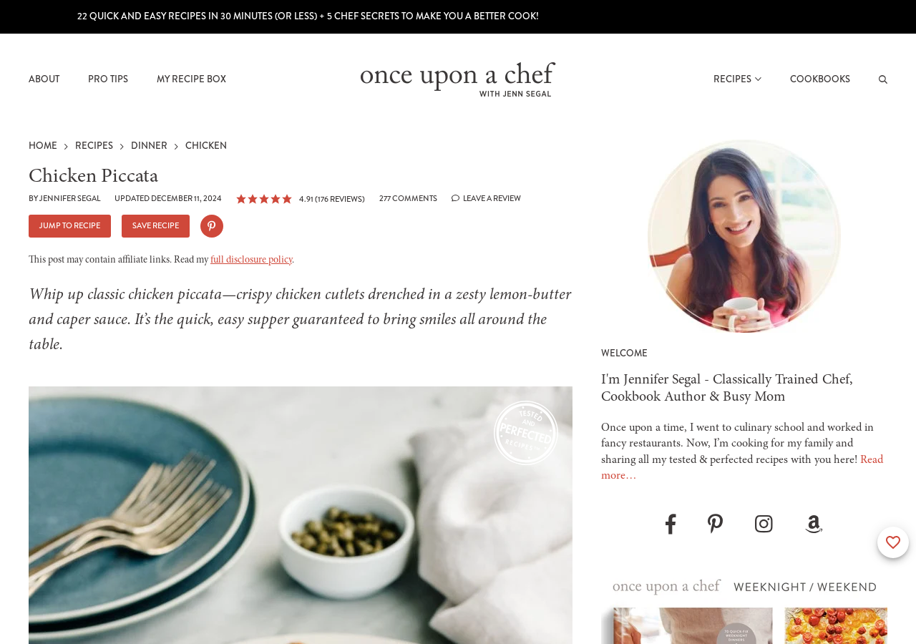
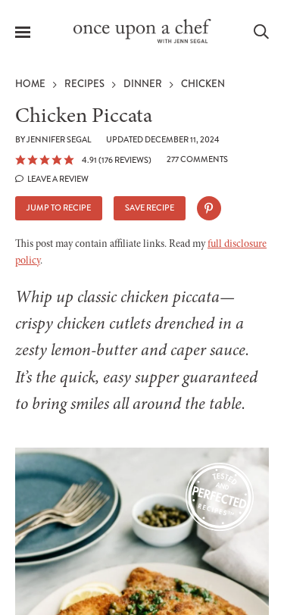

Search/filter patterns
Finding a specific recipe is easy but limited in scope:
- Instant Search Dropdown: When you click the search bar and start typing, an auto-suggest overlay instantly displays matching recipe titles with small photo thumbnails. This is extremely helpful for quick navigation if you already know what you want to cook.
- Simple Text Search Results: Pressing enter displays a simple grid of matching results. However, there are no sidebar filters or tags on the search page to refine your search (e.g., you can't search 'chicken' and then filter for 'dairy-free' or 'dinner only').
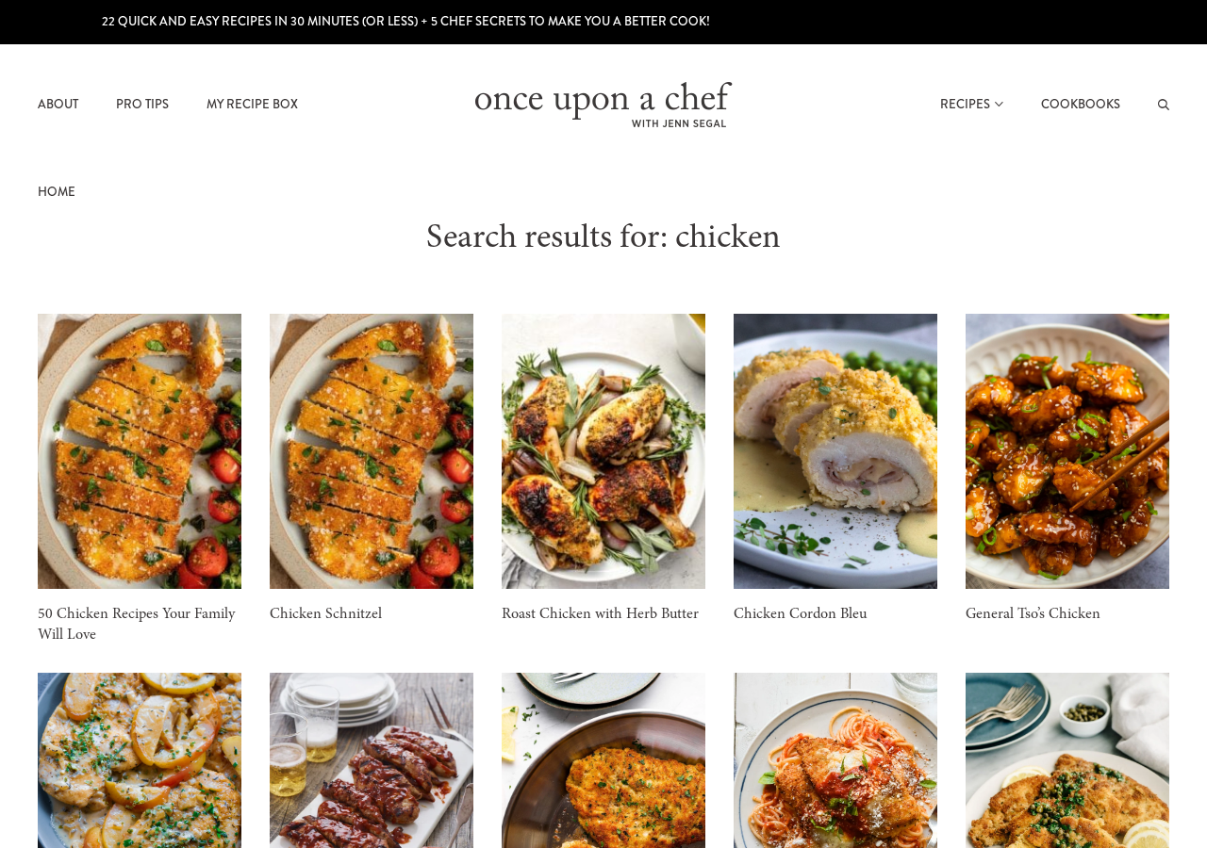

Guided cooking patterns
Once Upon a Chef is famous for its visual, step-by-step cooking model:
- Integrated Photo Walkthroughs: Unlike cooking apps that have a separate slideshow, Once Upon a Chef embeds the guided cooking directly in the blog post body. You scroll vertically through clear headings like "How to Make It" where each numbered step is paired with a photo showing the intermediate state of the ingredients.
- Visual Milestones: The photos focus on tricky culinary visual cues, such as the exact browning of butter, the thickness of a sauce, or the level of rise in a cake batter, making it a wonderful teaching tool.

Save/share patterns
The site uses a simple, proprietary bookmarking system to keep readers coming back:
- "Save Recipe" Integration: Clicking the 'Save Recipe' button near the top of the post or in the recipe card prompts a clean slide-out modal.
- My Recipe Box: To save recipes, you sign up for a free Once Upon a Chef account. Your saved recipes are then stored in your personalized "My Recipe Box" page, which is accessible directly from the main navigation header. It is a great way to save recipes from her site, but it cannot import recipes from external sites.
- Prominent Social Sharing: Sharing buttons for Pinterest, Facebook, and Email are everywhere, with Pinterest hover buttons appearing automatically on every single recipe image.
(Note: The "Save" CTA button and "My Recipe Box" navigation link can be clearly observed in the header of the actual Recipe Index and Recipe Detail screenshots above, which act as the access gate for saving and organizing recipes on the platform.)

Additional features worth noting
A few extra design and business-model features stand out:
- Bestselling Cookbook Funnel: The site acts as a major marketing engine for Jenn Segal's published cookbooks. Sidebar banners, footers, and recipe card links nudge you to purchase her physical cookbooks ("Once Upon a Chef: Weeknight/Weekend" and "The Cookbook"), blending digital content with physical publishing.
- Weekly Meal Plans: Jenn publishes curated "Weekly Meal Plans" that group 5-6 dinners and a dessert together, complete with a structured cooking sequence, providing great routine value for busy families.
- Personalized Chef Q&A: The comment section is monitored closely. If you ask a culinary question (e.g., "Can I swap sour cream for Greek yogurt in this cake?"), Jenn or her team frequently replies with professional, tailored advice within 24 hours.
(Note: The weekly meal plan collections and cookbook ads can be observed in the right-hand sidebar and bottom footer sections of the Recipe Index and Search screenshots above, showing their integrated, conversion-oriented placement.)

App Metadata Summary
- App Name: Once Upon a Chef
- Best known for: Polished, family-friendly cooking with professional testing
- Core angle: Family-friendly tested recipes
- Key Features:
  - Tested and perfected recipes aimed at enjoyable, stress-free everyday cooking.
  - Easy and elegant recipes with step-by-step photos for many occasions.
  - Professional chef background behind the site’s editorial lens.

